Assignment2
- Write a Context-Free Grammar for the language L = {wcw^{r} | w ∈ {a,b}* }, w ^{r} represents the reverse of w.

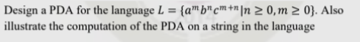

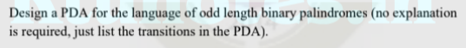
- Design a PDA for strings in which number of a’s is less than number of b’s.

- Minimize the following DFA using Myhill – Nerode theorem
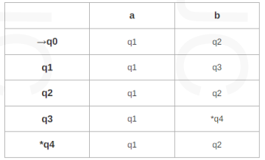
- Construct the Grammars in Chomsky Normal Form generating the set of all strings over {a,b} consisting of equal number of a’s and b’s.
- What is Greibach Normal Form (GNF)? Convert the following CFG to GNF
S → AA / a, A → SS / b

